Topic: Stack, Queue, 2D Array, and Circular Queue

Subject: Data Structures
Programming Language: Java
Task 1: Implement Stack and Queue Using Linked List
1. Stack Using Linked List
Problem Statement
A librarian places books on top of one another. The last book placed on the stack is the first book removed. The librarian can add a book, remove the top book, check which book is on top, and display all the books.
This scenario follows the LIFO (Last In, First Out) principle and uses a Stack implemented with a Linked List.

Basic Operations
- Push: Adds an element to the stack.
- Pop: Removes the top element from the stack.
- Peek: Displays the top element without removing it.
- Display: Shows all elements in the stack.
- Is Empty: Checks whether the stack is empty.
Algorithm
Push Operation
- Create a new node.
- Store the value in the node.
- Set the new node's next pointer to the current top.
- Update top to point to the new node.
Pop Operation
- Check whether the stack is empty.
- If empty, display an underflow message.
- Otherwise, remove the top node.
- Update top to the next node.

Java Program:
Stack Using Linked List
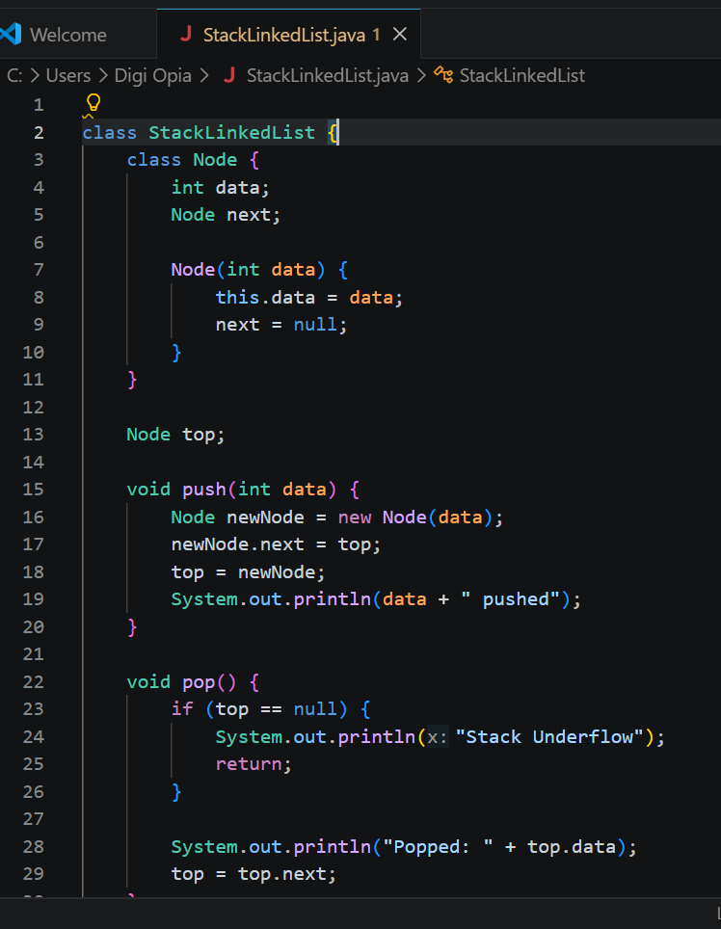

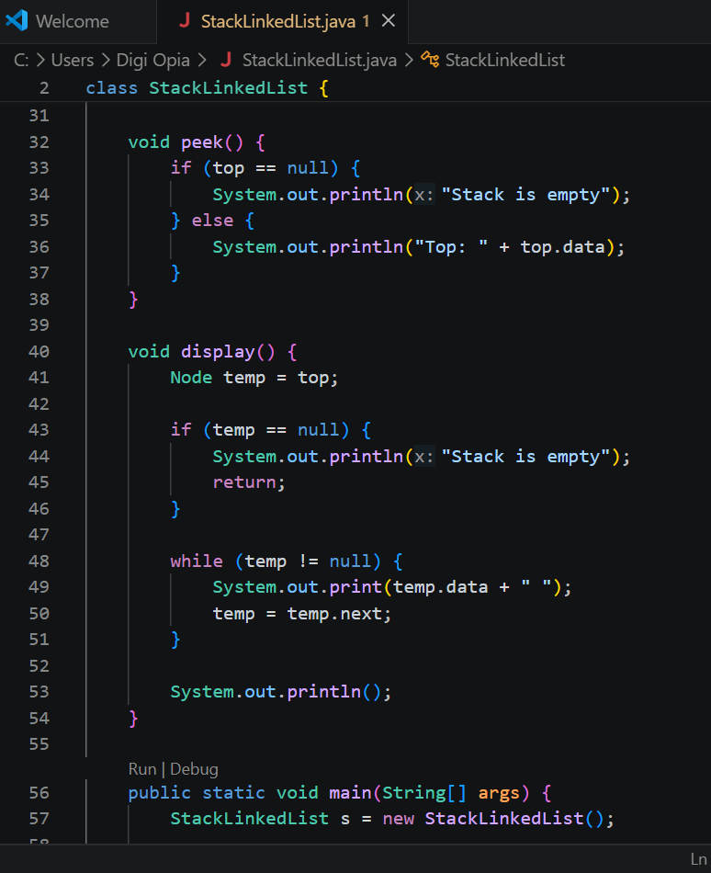

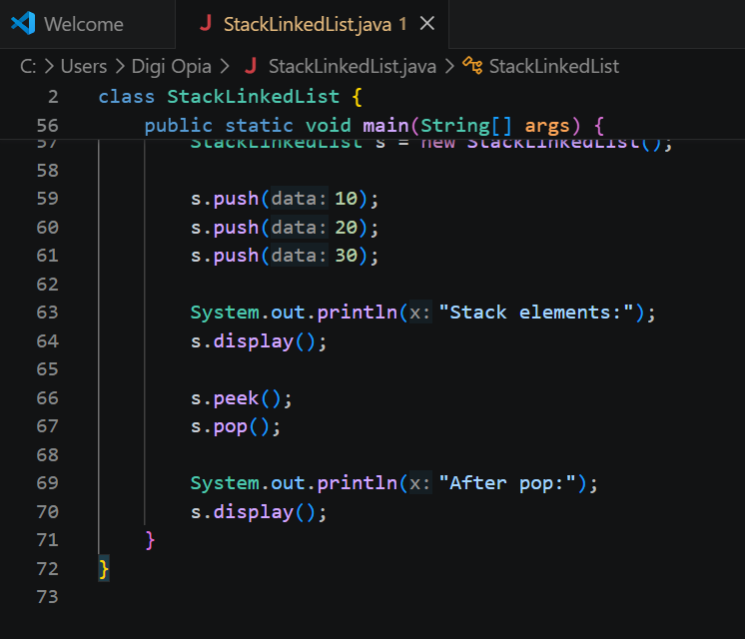

Output:
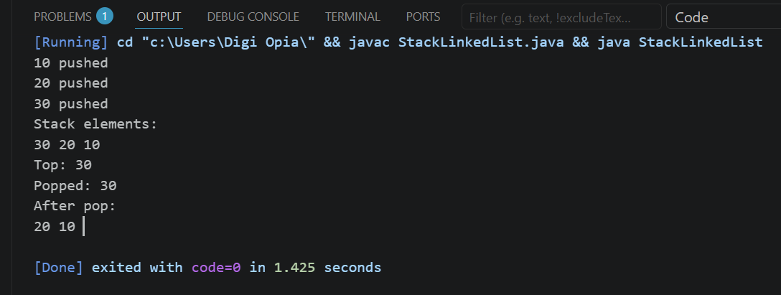

Real-World Applications
- Undo operation: Reverses the most recent action in a text editor.
- Browser history: Helps manage backward navigation.
- Function calls: Stores information about active function calls.
2. Queue Using Linked List
1. Problem Statement
A bank manages its customers using a queue. Customers join the queue when they arrive, and the customer who arrives first is served first. The bank system allows the staff to add customers to the queue, remove the customer who has been served, check the next customer, and display all waiting customers.
This system follows the FIFO (First In, First Out) principle and uses a Queue implemented with a Linked List.

Basic Operations
- Enqueue: Inserts an element at the rear.
- Dequeue: Removes an element from the front.
- Peek: Displays the front element.
- Display: Shows all elements.
- Is Empty: Checks whether the queue is empty.
Algorithm
Enqueue Operation
- Create a new node.
- Store the value in the node.
- If the queue is empty, set both front and rear to the new node.
- Otherwise, link the current rear to the new node.
- Update rear to the new node.
Dequeue Operation
- Check whether the queue is empty.
- If empty, display an underflow message.
- Otherwise, remove the front node.
- Update front to the next node.
- If front becomes null, set rear to null as well.

- Java Program:

Queue Using Linked List
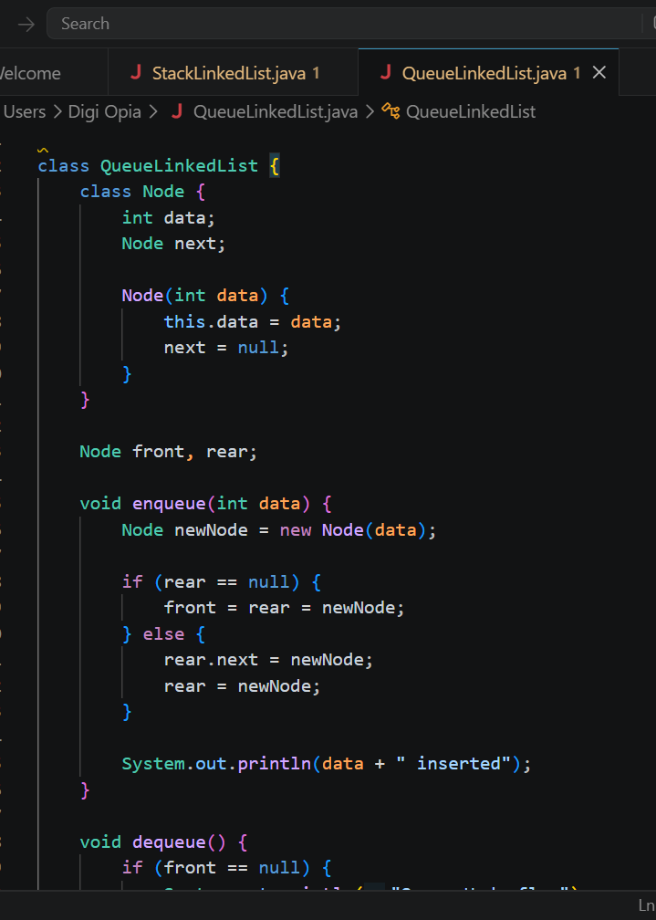

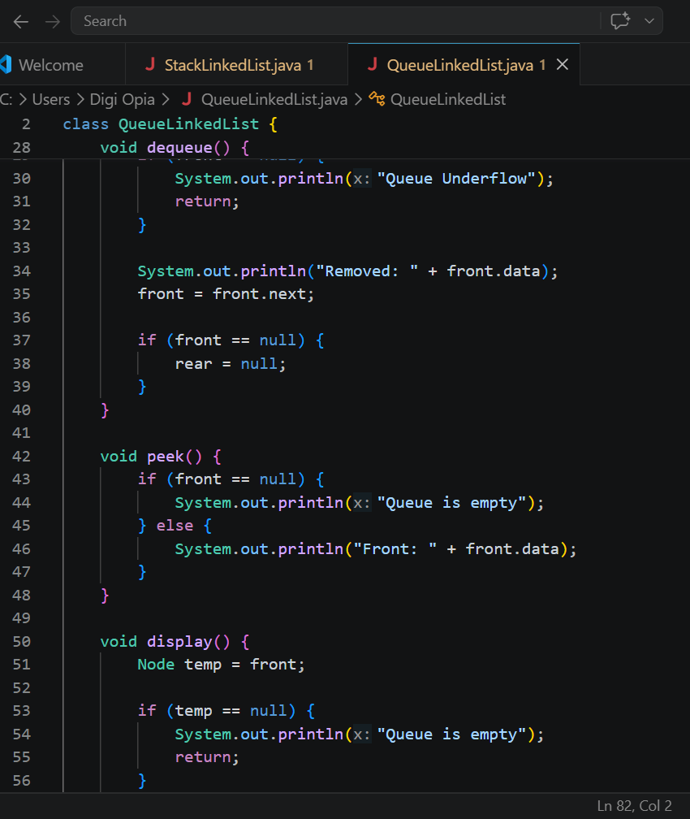
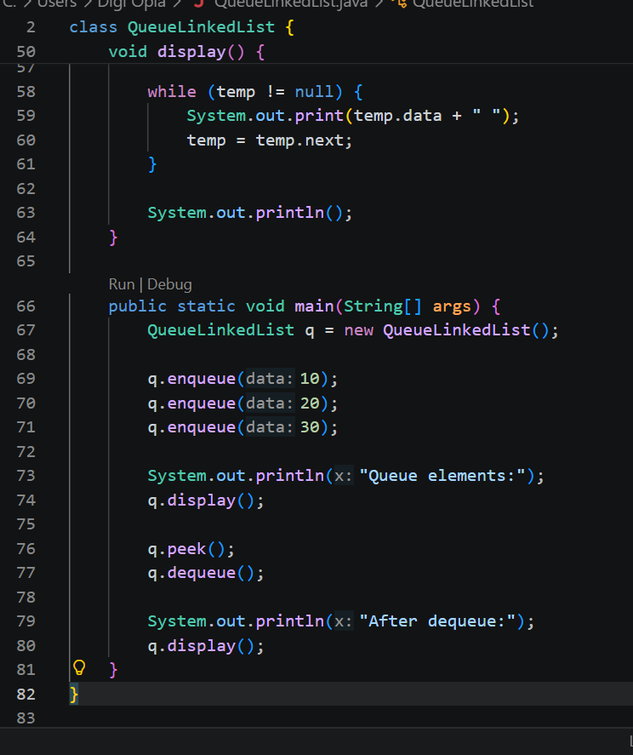

Output:
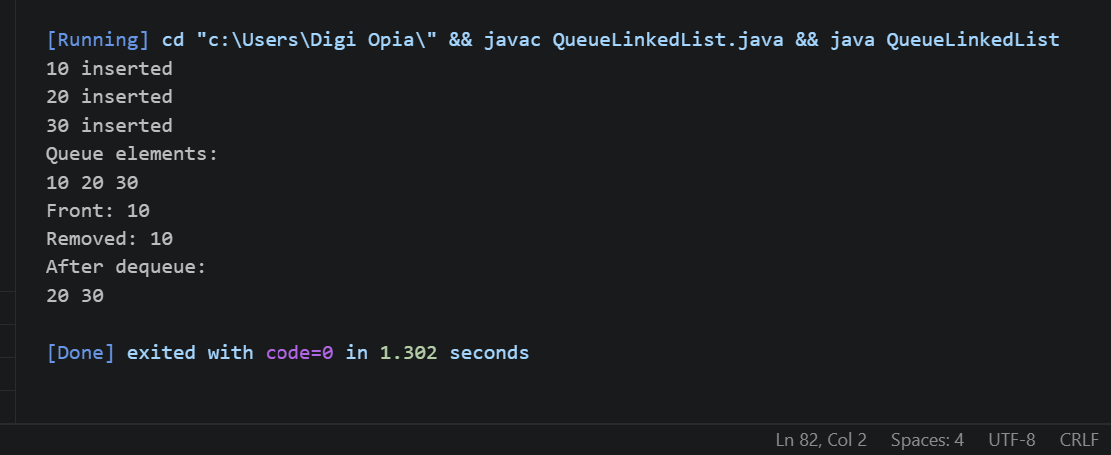
Task 2: Implement 2D Array and Circular Queue Using Array

3. Two-Dimensional Array (2D Array)
1. Problem Statement
A teacher wants to store and display the marks of 2 students in 3 subjects. The teacher enters the marks of each student, and the system stores them in a two-dimensional array containing 2 rows and 3 columns. The system then displays the marks in table form and retrieves the mark of a particular student in a specific subject.
This program uses a Two-Dimensional Array (2D Array) to store and manage student marks.

Basic Operations
- Declaration: Creates an array.
- Initialization: Assigns values to array elements.
- Traversal: Visits each element.
- Access: Retrieves an element using its row and column indexes.
- Update: Changes the value stored at a particular position.
Algorithm
- Declare a 2D integer array.
- Use nested loops to input values.
- Use nested loops to display the array.
- Use row and column indexes to access or update an element.

- Java Program:

2D Array

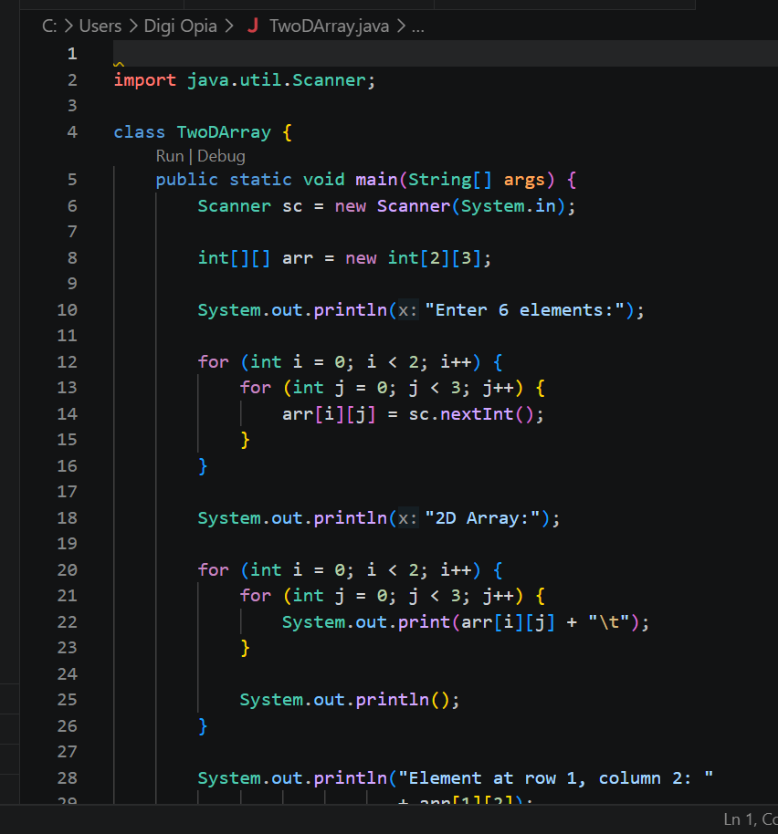

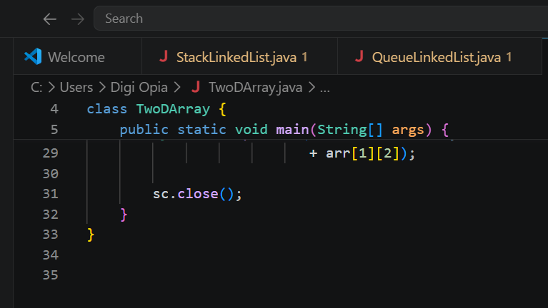
Output:
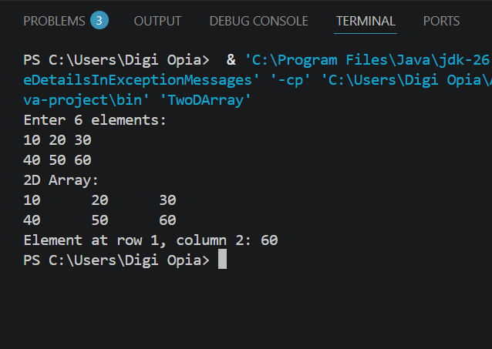

Real-World Applications
- Matrices: Stores mathematical matrix elements.
- Student marksheets: Stores marks for multiple students and subjects.
- Chessboards: Represents positions on a board.

4. Circular Queue Using Array

Program Statement:
A bank uses a Circular Queue using an array to manage customer token numbers, with a capacity of five customers. The system allows staff to insert and remove customers, check the next customer, display the queue, and check whether it is empty or full.

Basic Operations
- Enqueue: Inserts an element at the rear.
- Dequeue: Removes an element from the front.
- Peek: Displays the front element.
- Display: Shows all elements in queue order.
- Is Empty: Checks whether the queue is empty.
- Is Full: Checks whether the queue is full.
Algorithm
Enqueue Operation
- Check whether the queue is full.
- If full, display an overflow message.
- If empty, set front to 0.
- Move rear to its next circular position.
- Insert the new element.
Dequeue Operation
- Check whether the queue is empty.
- If empty, display an underflow message.
- Remove the front element.
- If it was the last element, reset front and rear to -1.
- Otherwise, move front to its next circular position.

- Java Program:

Circular Queue Using Array
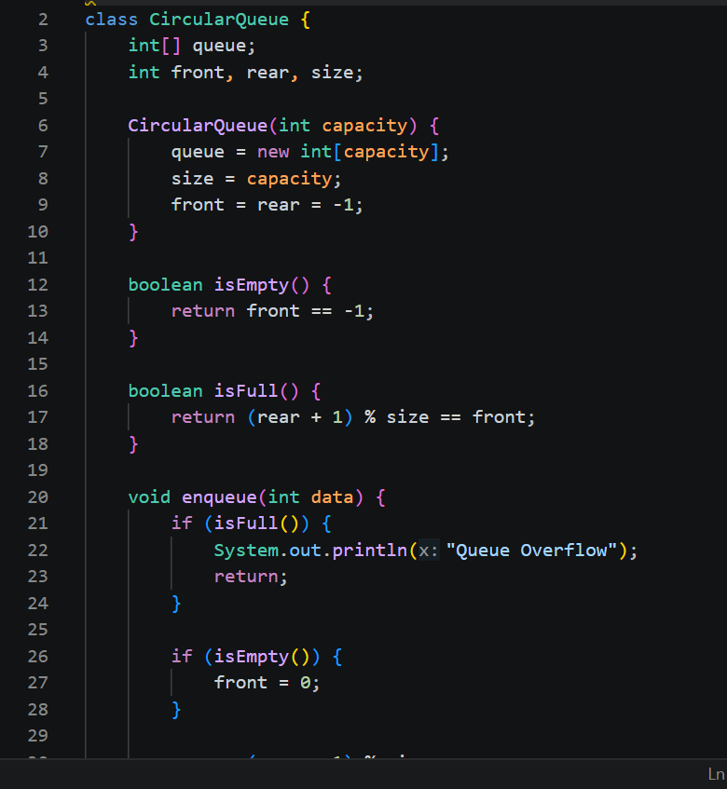

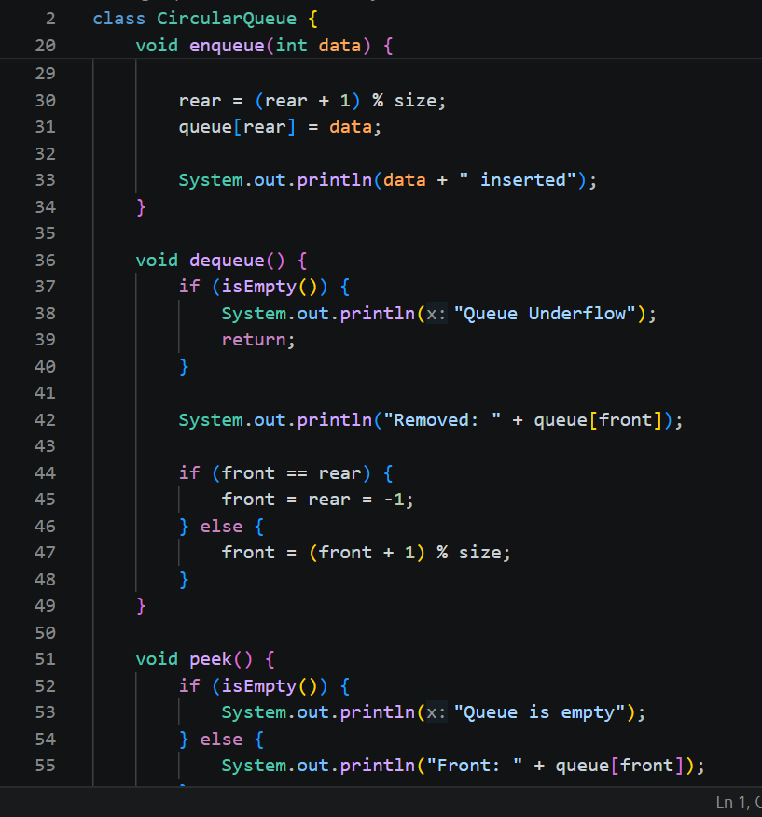

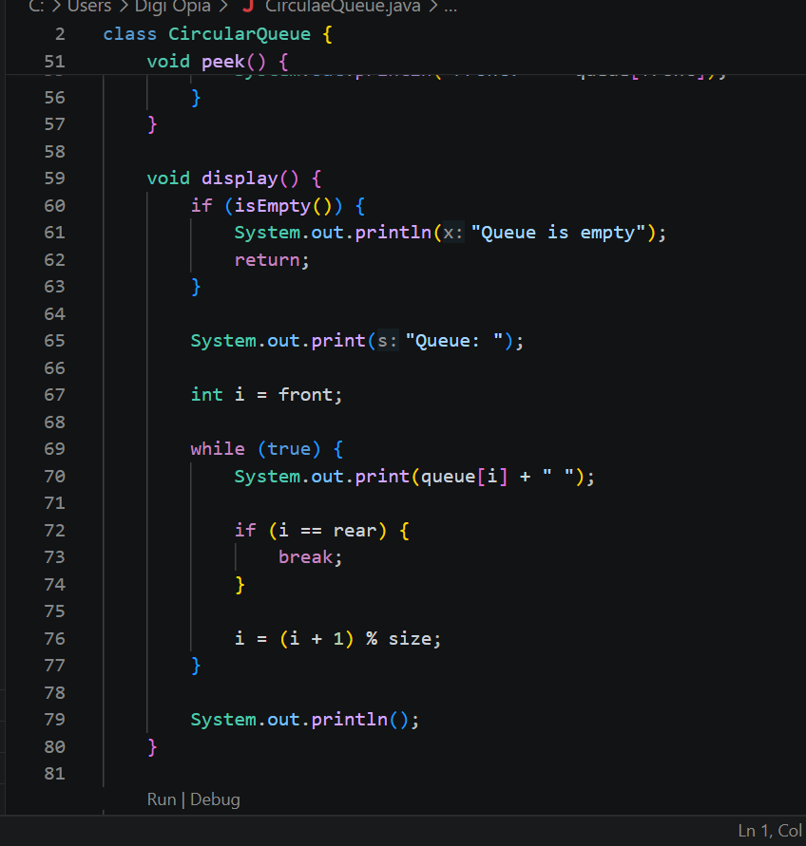

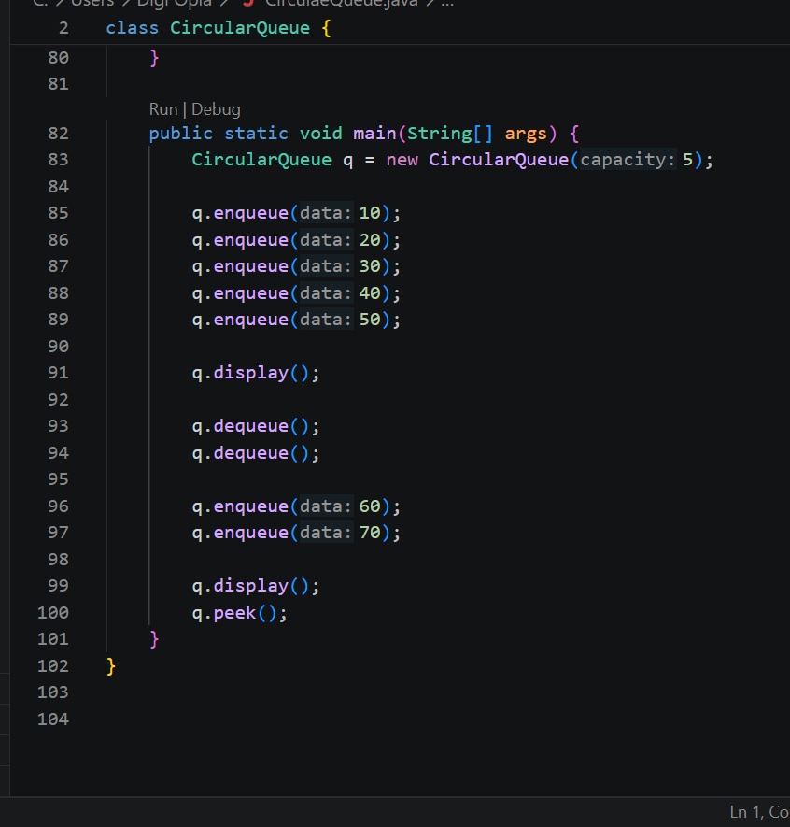

Output:
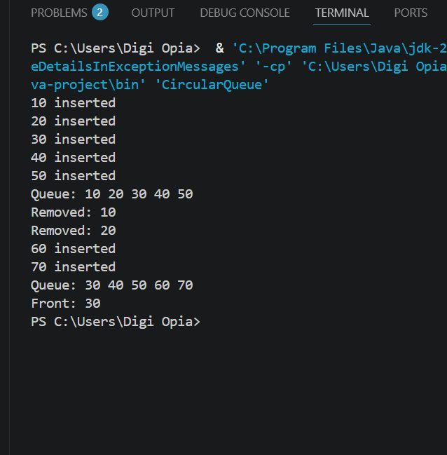

Real-World Applications
- CPU scheduling: Helps manage tasks in cyclic scheduling systems.
- Keyboard buffers: Can store input temporarily.
- Streaming systems: Can maintain a fixed-size buffer of recent data.

